Task 1. Handling Events in React
a) Create a simple component with a button labeled “Toggle Message.”
b) When the button is clicked, toggle a message on the screen that says “Hello, welcome to React!” This message should disappear when the button is clicked again.

Please find the screenshot below for the button component.
- It contains a button named ‘Toggle Message’, with ‘OnClick’ event.
- When we click on ‘Toggle Message’ button, it toggles (hide/ show) a message as in below screenshot.
- This component is called from App.jsx file. A prop is passed for the name to be displayed in the component.
- Thus, when the button is clicked, it displays message with name sent as prop to the component.
- When the button is clicked again, it hides the message.

MessageButton.jsx:
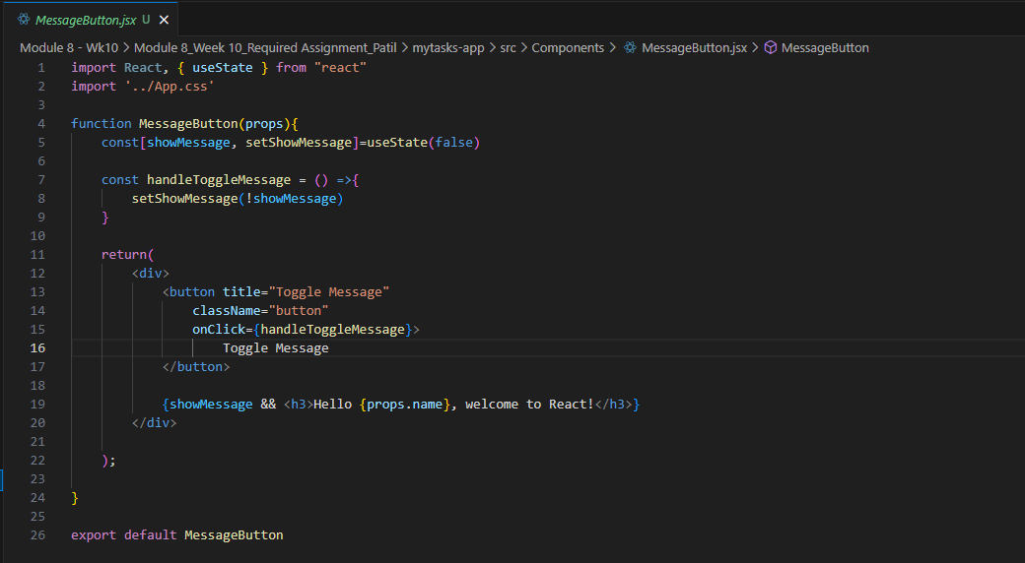

App.jsx:
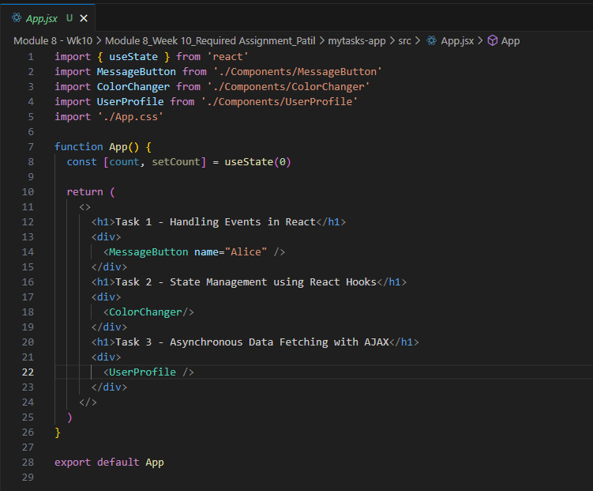

When button clicked, the message is shown:
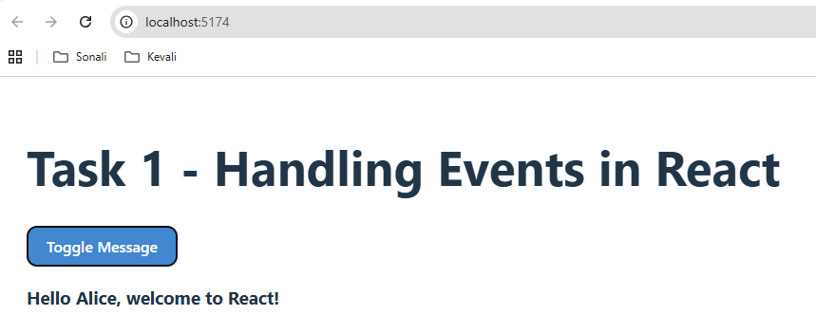

When the button is re-clicked, the message is hidden

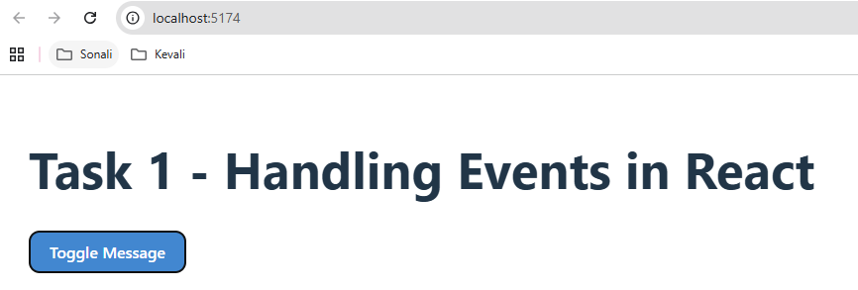

Task 2. State Management using React Hooks
a) Build a component called ColorChanger. This component should have a text input where users can enter a colour name (e.g., “blue”).
b) The component should display a box that changes colour based on the input.
c) As the user types into the input, the box should automatically update to the new colour if it’s a valid colour name.

Please find screenshots below for the ColorChanger component.
- It has a textbox for user to enter the name of the color, he/she wants to set for the div box below.
- When the user types the color name into the input box, the background color of the div box gets updated automatically.
- If the user inputs invalid color name, the background color of the div box is set to transparent and the error message is displayed below the div box.
- This component is called from App.jsx file.

ColorChanger.jsx:
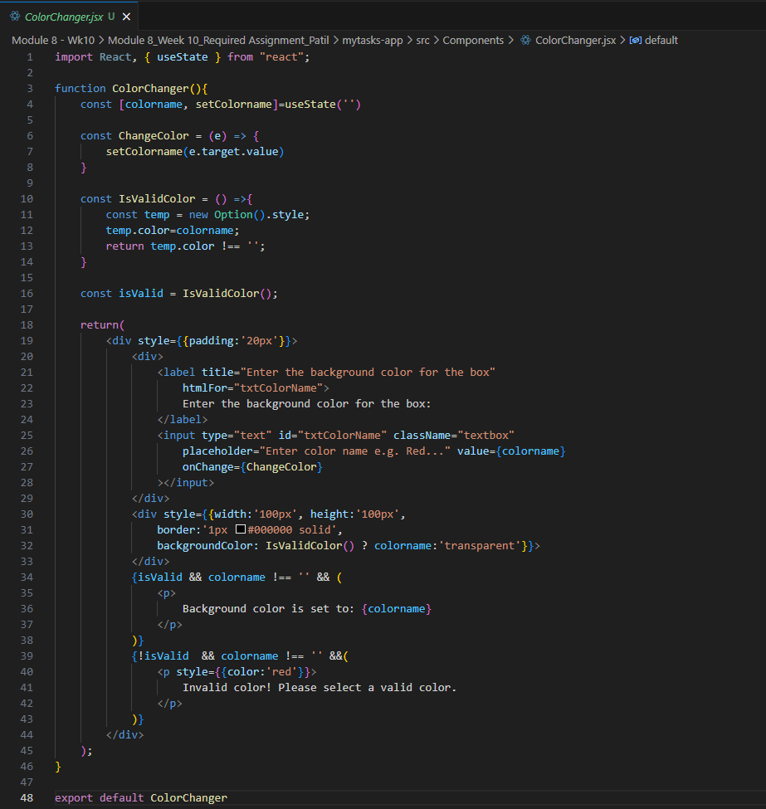

App.jsx:
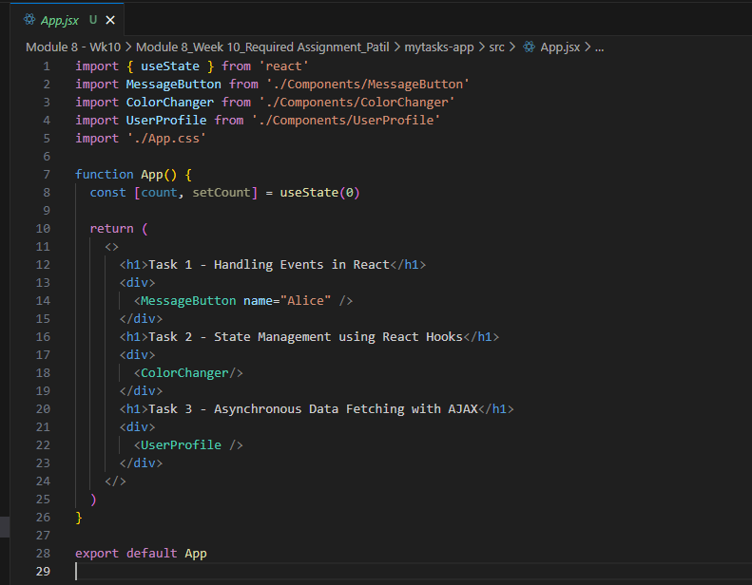

The output: When color name is entered in the textbox, the background color for the below div is set automatically.
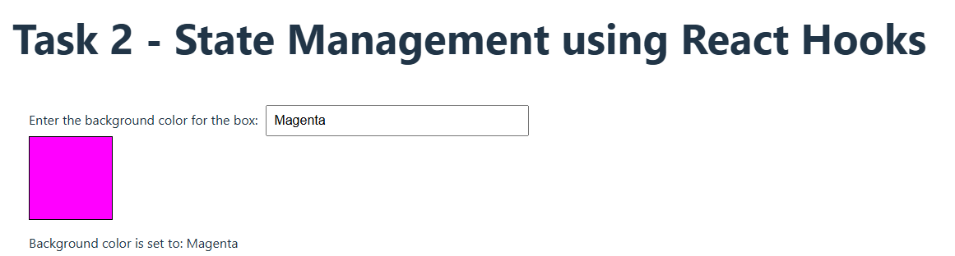

Error Message:
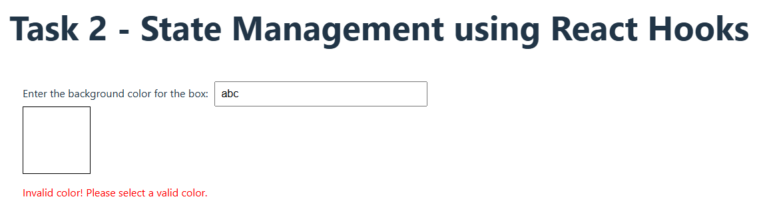

Task 3. Asynchronous Data Fetching with AJAX
a) Create a UserProfile component that fetches user data from an API (for example, https://jsonplaceholder.typicode.com/users/1) and displays the user’s name, email, and address on the page.
b) Display a loading message while data is being fetched.

Please find the screenshots for the UserProfile component.
- This component has a input box for the user to key in the User ID (type is set as number).
- When the user keys in valid User ID, the profile information for that user is fetched from ‘https://jsonplaceholder.typicode.com/users’ API and displayed in profile information section automatically.
- While the data is being fetched, the loading message is displayed in profile information section.
- If there is no User ID, entered in the input box, the profile information section displays, ‘No data to display’ message.
- When invalid User ID is entered, or any error occurs, the error message is displayed in the profile information section.
- This component is called from App.jsx file.

UserProfile.jsx
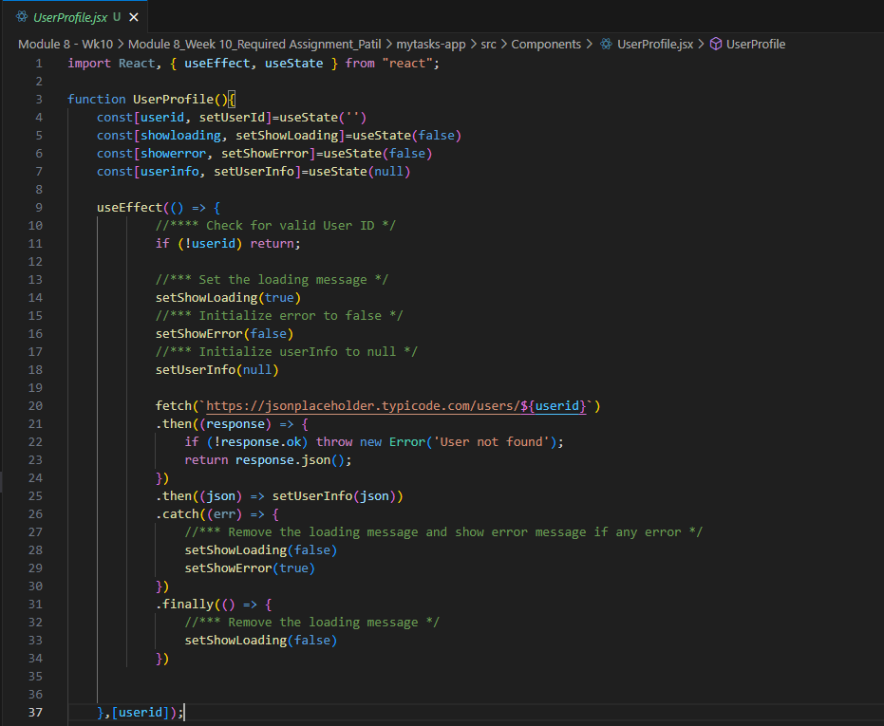

The code continues in the below screenshot…
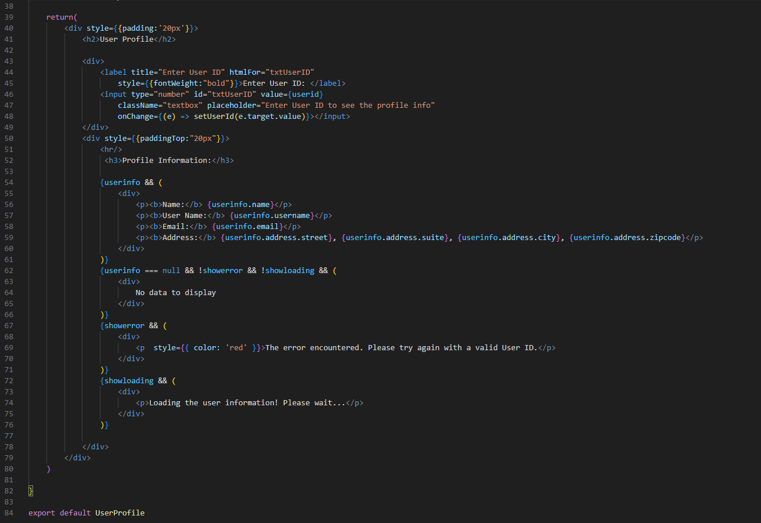

App.jsx:
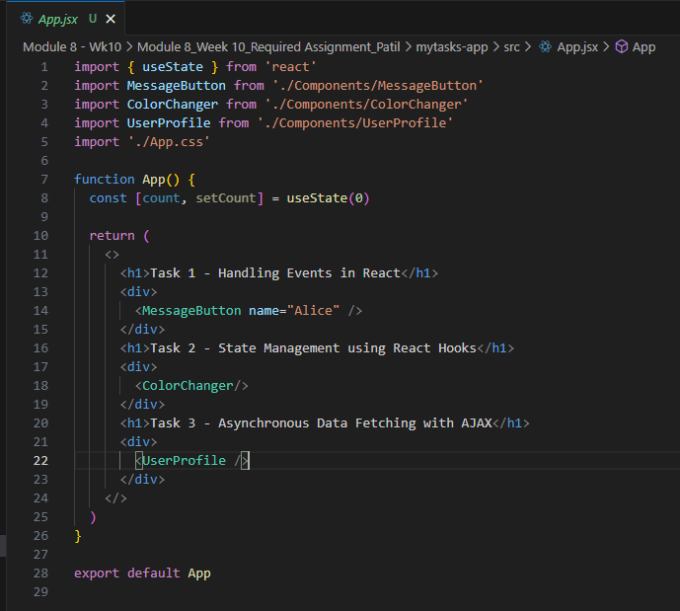
Data fetched from API for valid User IDs:
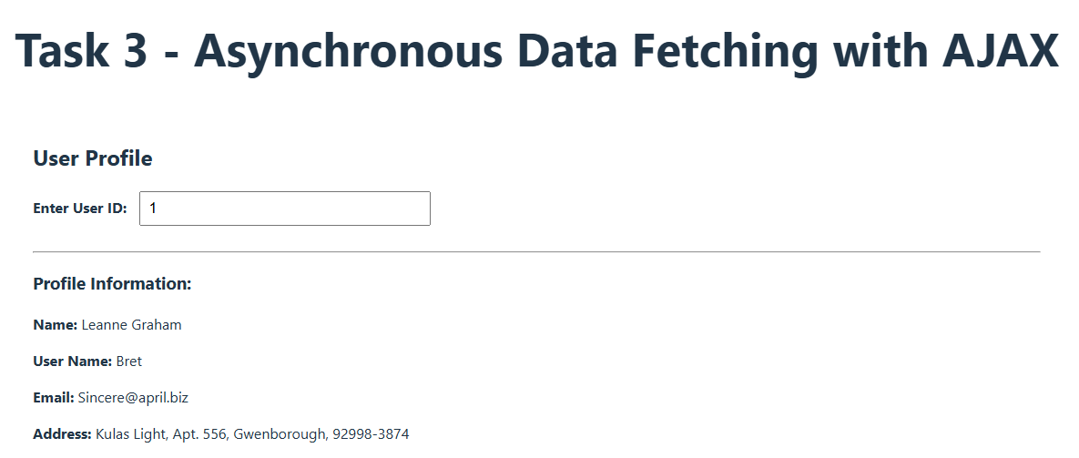

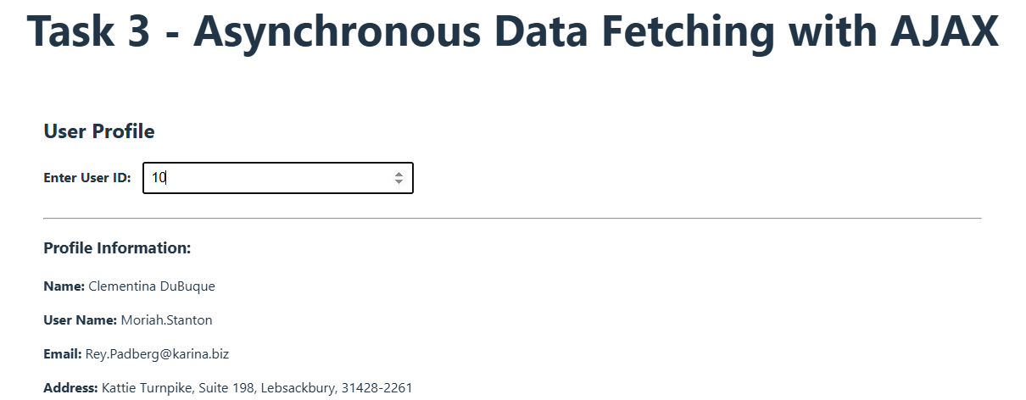

Error:
